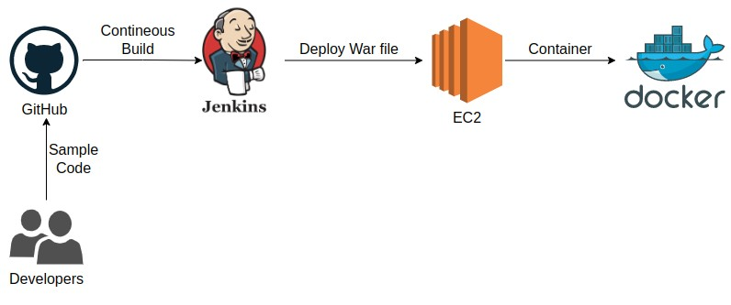

Step 1 - Developers push their code in on one Repository

Step 2 – With Github we can check our code and Different repositories.
- Copy repository URL for connection with VM and Jenkins.
- We can create one Token for authentication with Github
( For security reason Token get dissapear after generate,
so we have to copy that token and save it for later )
Step 3 – Create one Ec2 Instance and connect with terminal.
- Open port no 22 in security group
- Install Jenkins and Java package on VM.
- Install and run Docker on VM and start service.
Step 4 – Add user with Jenkins and Install all necessary Plugins.
- Publish over ssh plugin should be updated.
- setup Manage Jenkins -> Configure System -> setup with Github URL path
Step 5 - Create Jenkins job

A) Source Code Management
Repository : https://github.com/ThinkitiveTech/hello-world.git
Branches to build : */master

B) Build
Root POM: pom.xml
Goals and options : clean install package

C) send files or execute commands over SSH
Name: docker_host
Source files : webapp/target/*.war
Remove prefix : webapp/target
Remote directory : //opt//docker
Exec command[s] :

docker stop ThinkTech_demo;
docker rm -f ThinkTech_demo;
docker image rm -f ThinkTech_demo;
cd /opt/docker;
docker build -t ThinkTech_demo .

D) send files or execute commands over SSH
Name: docker_host
Exec command : docker run -d --name ThinkTech_demo -p 8090:8080 ThinkTech_demo

Step 6 - Login to Docker host and check images and containers. (no images and containers)

docker images
docker ps
docker ps -a

Step 7- Execute Jenkins job (Build Now)

Step 8 - check images and containers again on Docker host. This time an image and container get creates through Jenkins job

docker images
docker ps
docker ps -a

Step 9 - Access web application from browser which is running on container

<docker_host_Public_IP>:8090

